|  |  |
| --- | --- |
|  | **ATTACHMENT C**  **Portland Public Schools**  **Career Learning Requirements** |

* 1. **Registration on PPS Partner Connect**
     1. The Contractor is required to register on the District’s Career Learning database tool, PPS Partner Connect, which is located at <https://www.pps.net/partnerconnect>
* When registering, the Contractor must follow the detailed instructions attached.
  + 1. The Contractor must offer Career Learning opportunities as follows:
       1. If this contract has a value at or exceeding $100,000 but less than $1,000,000, Contractor must:
          - Register with PPS Partner Connect and offer at least two Career Learning opportunities to PPS students. For contracts lasting longer than one year, the Contractor must offer at least two opportunities every year during the active term of the contract.
       2. If this contract has a value at or exceeding $1,000,000, Contractor must:
          - Register with PPS Partner Connect and offer at least four Career Learning opportunities to PPS students. For contracts lasting longer than one year, Contractors must offer at least four opportunities every year during the active term of the contract; and
          - Register to participate as an exhibitor in the Portland Workforce Alliance’s annual Northwest Youth Careers Expo every year during the active term of the contract. Follow the detailed registration instructions attached. (If Contractor is unable to participate as an exhibitor, Contractor must register to participate as a sponsor at an equivalent level.)
  1. **Program Administration**
     1. Contractors will report registration with PPS Partner Connect to the District prior to contract execution:
* Contractors must submit the registration confirmation email or similar proof of registration to the District with its signed contract.
  + 1. Contractors will receive requests from District Career Coordinators to provide Career Learning opportunities to PPS students.
    2. Contractors will coordinate with the District’s Career Coordinators to plan, schedule, and conduct the Career Learning events or activities.
    3. Career Coordinators will coordinate student participation before and during scheduled events and activities.

**Please send any questions about these Career Learning Requirements to** [**careerpath@pps.net**](mailto:careerpath@pps.net?subject=Career%20Learning%20Requirements)

PPS PARTNER CONNECT— CONNECTING PARTNERS AND PPS STUDENTS

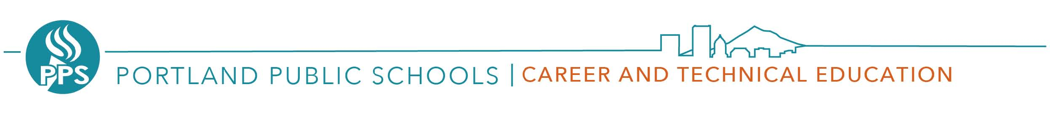

PPS Partner Connect is our new web-based tool which makes it easy for parents, alumni and industry professionals to connect with K-12 educators. Professionals can share their skills and expertise to bring real-world, authentic learning opportunities to all our students helping to create the next generation of innovators. Through in-person matches and virtual sessions, professionals can help students and teachers connect their classroom experiences to the world of work. ***Together we can make a difference.***

Students need context for what they are learning in the classroom. *PPS Partner Connect can help match your expertise and insight to connect with the schools and students in your community. This easy-to-use tool enables educators to match student-learning needs with professionals whose skills fit their request.*

**Benefits to professionals and employers:**

* Provides meaningful ways to engage in education
* Connects professionals with educators based on their skills, volunteer interests, and location
* Exposes future workforce to career opportunities
* Allows companies to centralize and scale education outreach
* Tracks employee engagement based on a variety of metrics and generates reports
* Enhances employee engagement and achieves corporate responsibility goals
* Demonstrates your commitment to your community through volunteering

**How it works:**

* Community members and professionals register and set up a profile at https://www.pps.net/partnerconnect
* Career Coordinators create a request based on a topic or activity at their school that can benefit from an industry connection.
* PPS Partner Connect enables high school Career Coordinators to match the skills of industry professional(s) with requests and helps mediate the process of connecting them to the right classroom and students.
* Career Coordinators coordinate with professionals who can choose to accept matches and connect in-person or virtually to share expertise.

ENGAGE— PREPARE — INSPIRE

The District is committed to equal opportunity and nondiscrimination in all its educational and employment activities. The District prohibits discrimination based on

race; national or ethnic origin; color; sex; religion; age; sexual orientation; gender expression or identity; pregnancy; marital status; familial status; economic status or

source of income; mental or physical disability or perceived disability; or military service.



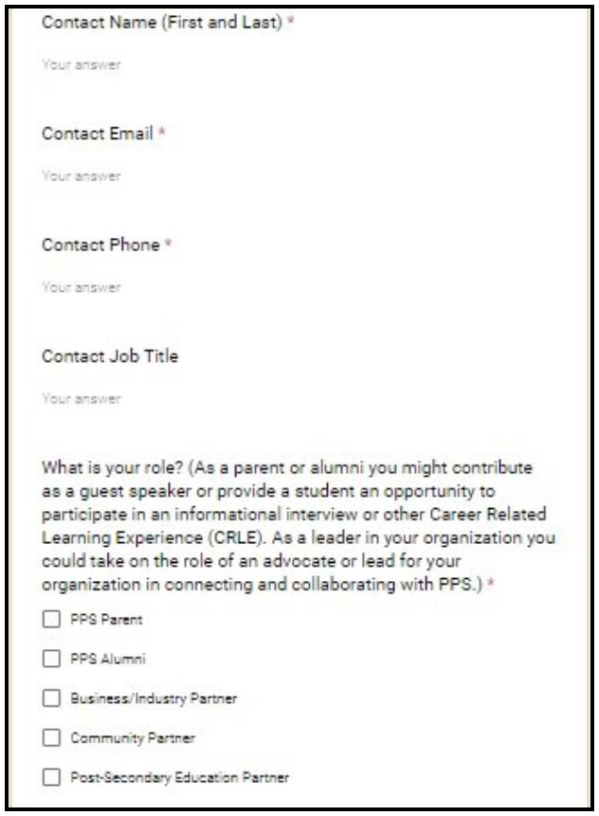

PPS Partner Connect Guide

**STEP 1 -**

* + - 1. Go to PPS Partner Connect <https://www.pps.net/partnerconnect> and complete the Partner Intake Survey

1. Complete your Profile Information:
2. Please provide your first and last name, the best e-mail to contact you, and best contact phone number.
3. Please select your role: (Check all that apply)

* PPS Parent - The parent of a student or students
* PPS Alumni - Those who have graduated from a PPS school.
* Business/Industry Partner - Those working in the business/industry sector including those who have a contract with PPS.
* Community Partner - Community-based pro-grams and organizations providing direct or indirect support to our schools and students.
* Post-Secondary Education Partner - Apprentice & trade organizations, community colleges, other Higher-Ed institutions
* Volunteer - Those who wish to volunteer or are currently volunteering with PPS

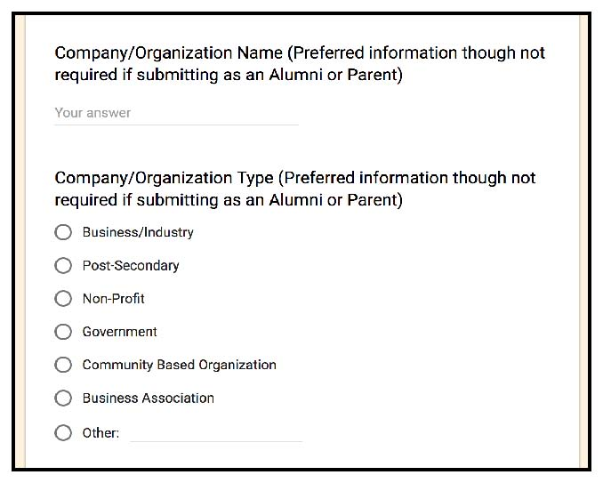**STEP 1 (Cont.)**

1. If you are submitting on behalf of a company or organization:
2. Please provide your company/organization name.
3. Please select a type that best matches your company/organization.

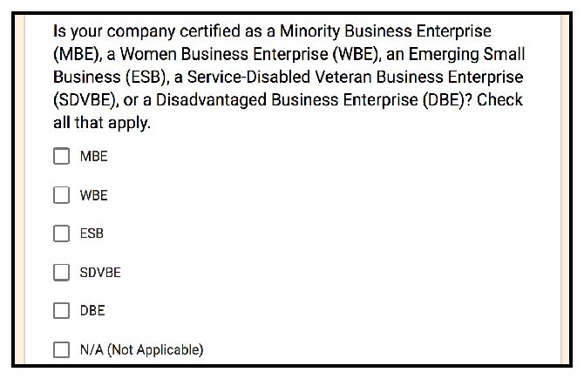

**STEP 2 -**

If your company is certified as a MBE, WBE, ESB, SDVBE, and/or DBE, please mark all that apply. If this does not apply, please mark N/A.

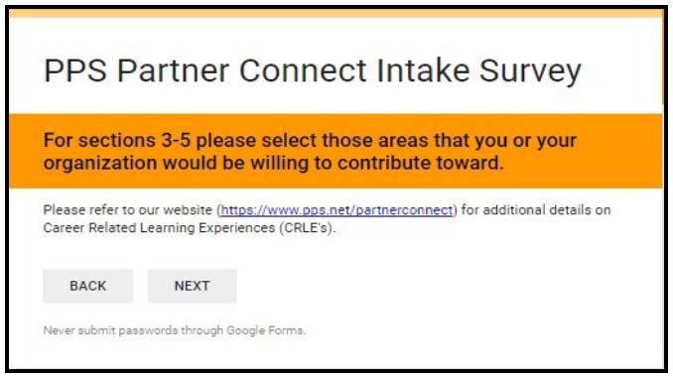



Career Related Learning Experiences are structured student activities that connect academic content and career-related learning to real life applications. In PPS we’ve broken them out into three tiers:

1. Career Awareness (primarily grades 7-9)

2. Career Exploration (primarily grades 9-11)

3. Career Preparedness (primarily grades 11-12)

**STEP 3-**

**Career Awareness** activities are designed to help students develop basic awareness of jobs and careers by interacting with CTE professionals. These experiences also help students understand the education and skill requirements for success in various fields.

Please select the experiences that you are interested in providing.

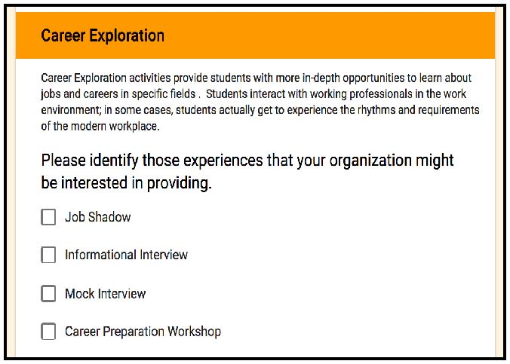

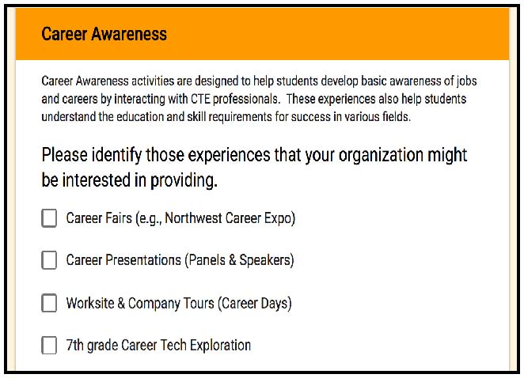

**STEP 4 -**

**Career Exploration** activities provide students with more in-depth opportunities to learn about jobs and careers in specific fields. Students interact with working professionals in the work environment; in some cases, students actually get to experience the rhythms and requirements of the modern workplace.

Please select the experiences that you are interested in providing.

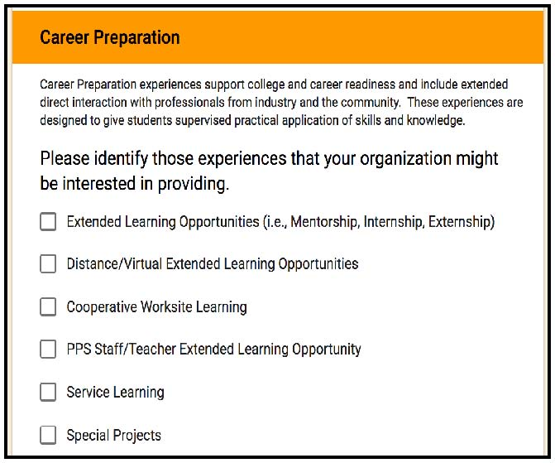

**STEP 5 -**

**Career Preparation** experiences support college and career readiness and include extended direct interaction with professionals from industry and the community. These experiences are designed to give students supervised practical application of skills and knowledge.

Please select the experiences you are interested in providing.





**STEP 6 -**

Please select the additional contributions or opportunities you would be interested in.

If you are interested in volunteering, please select “Volunteer.” (e.g., guest speaker, field trips, classroom help, 7th grade Career Tech Exploration)

Examples of technology and equipment donations could include welding machines and materials, robots, construction tools, 3D printers, or possibly computers that would meet program recommendations.

PPS CTE Advisory Committees provide assistance to and promote the development of Career and Technical Education Programs to meet the needs of students, teachers, business and industry, and the community.

For more information on the NW Youth Careers Expo, please visit

http://www.portlandworkforcealliance.org/.

**STEP 7 -**

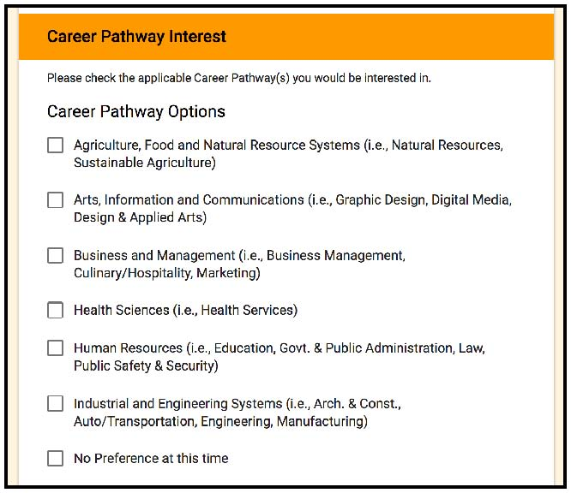

Please select the Career Pathway Options that are applicable to your interest(s). For more in-depth descriptions of the Career Pathway, please visit https://pps.net/pathways.

**Final Step -**

Thank you for completing our survey! You will receive an auto reply email once you have submitted the form. If for some reason your do not receive an email, please email careerpath@pps.net and we will follow-up with you.

For additional information please visit:

https://www.pps.net/partnerconnect

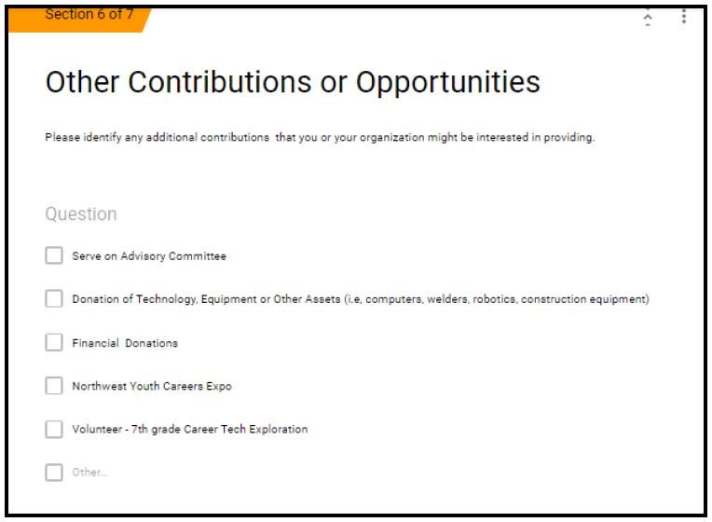

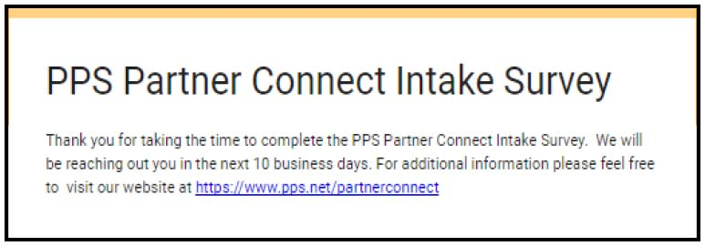



**About the NW Youth Careers Expo**

The annual NW Youth Careers Expo, hosted by the nonprofit Portland Workforce Alliance, is the state’s largest career education experience for high school students. It shows students the region's amazing diversity of career opportunities, as well as the skills and education needed for those jobs.

The Expo's goals are to connect employers to their future workforce and help students make informed, inspired decisions about their education after high school – whether they choose a four-year university, community college or apprenticeship training center. The Expo grows every year, attracting many thousands of students and more than 100 of the region’s top employers and postsecondary partners.

**Expo sponsor and exhibitor opportunities**

**Become a sponsor:** Generous sponsors make the Expo possible. Sponsors also invest in the year-round work of PWA, supporting high school students and the region’s future workforce.

**How your sponsorship helps:** Your sponsorship helps pay for Expo costs. Our expenses include facility rental, booths, personnel and the PWA Breakfast. Our expense budget also includes significant funds to help high schools cover the costs of student transportation and substitute teachers.

**Become an exhibitor:** Join the region’s leading businesses and organizations in telling students about career opportunities. Our exhibitors include top employers from every major sector, such as health care, business, technology, advanced manufacturing, construction, clean energy, government and the creative industries. They also include colleges and other postsecondary partners.

**Registration is easy**

**Become a sponsor:** Go to www.portlandworkforcealliance.org/expo and click on “Sponsor the Expo.” Register online or use the printable form.

**Become an exhibitor:** Go to www.portlandworkforcealliance.org/expo and click on “Become an exhibitor.” Register online or use the printable form.

**Questions? Want to learn more?**

PWA works with employers to offer career-learning experiences for students year-round, including career days, mentorship programs, internships, mock interviews and classroom presentations.

Visit PWA’s “Contact us” page at [http://www.portlandworkforcealliance.org/](http://www.portlandworkforcealliance.org/%20)